Duane Day Jr
CS-255
6/20/2026
CS-255 Project 2

UML Diagrams

UML Use Case Diagram
The use case diagram shows how customers, instructors, administrators, and the DMV system interact with DriverPass. Customers can register, log in, view training materials, schedule lessons, take practice tests, and make payments. Instructors can view appointments and record lesson results. Administrators manage users, schedules, training content, and DMV updates.
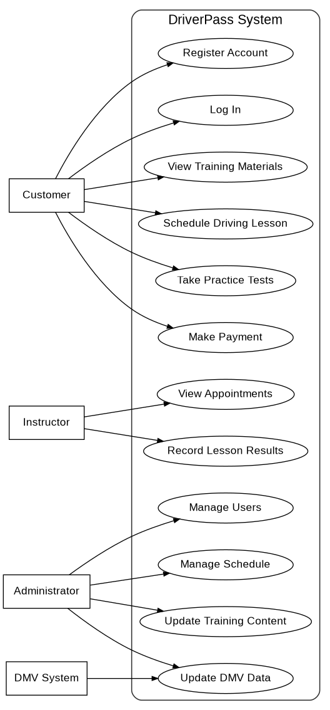

UML Activity Diagrams
The first activity diagram shows how a customer schedules a driving lesson. The system checks instructor and vehicle availability before saving the appointment. If a time is not available, the customer can select a different date and time.
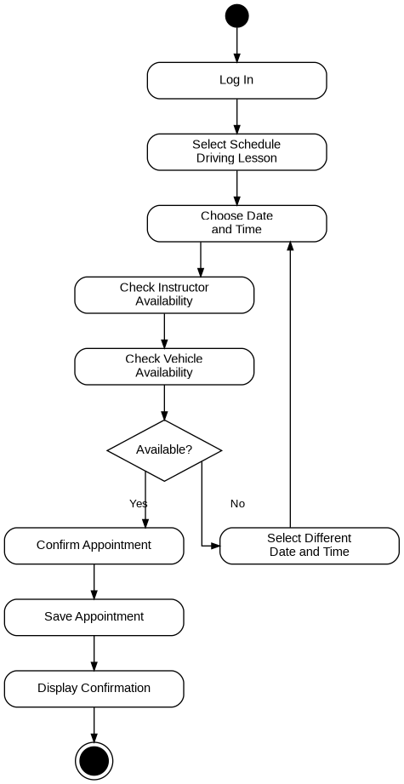

The second activity diagram shows how a customer takes a practice test. The customer logs in, selects a test, answers the questions, submits the test, and receives a saved score.
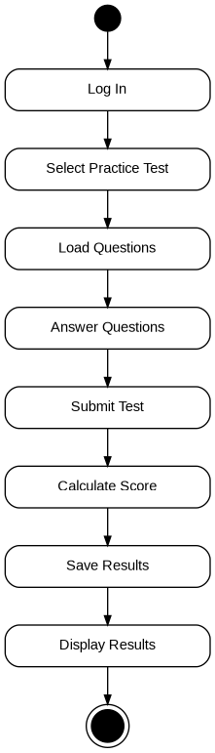

UML Sequence Diagram
The sequence diagram shows the order of communication when a customer schedules a driving lesson. The customer sends the request to the DriverPass system. The system checks the database, instructor schedule, and vehicle schedule before confirming the appointment.
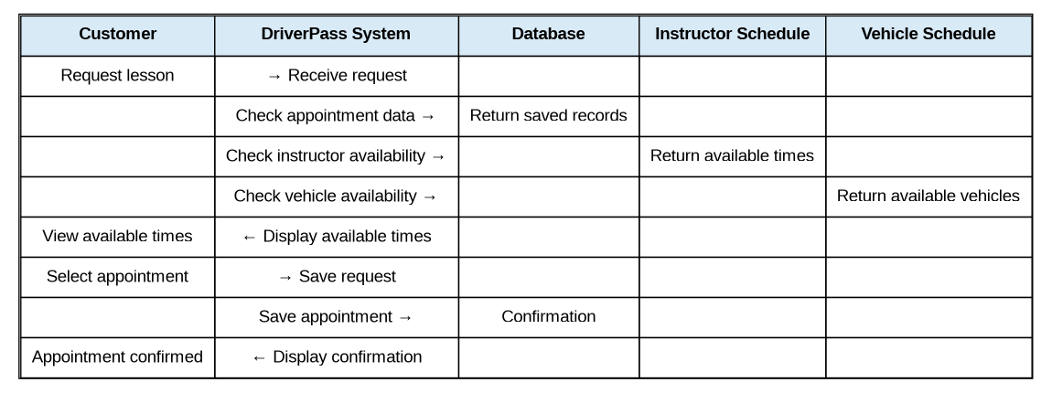

UML Class Diagram
The class diagram identifies the main classes and attributes needed for the DriverPass system. These classes support customer accounts, appointments, instructors, vehicles, practice tests, training content, and administrative reporting.
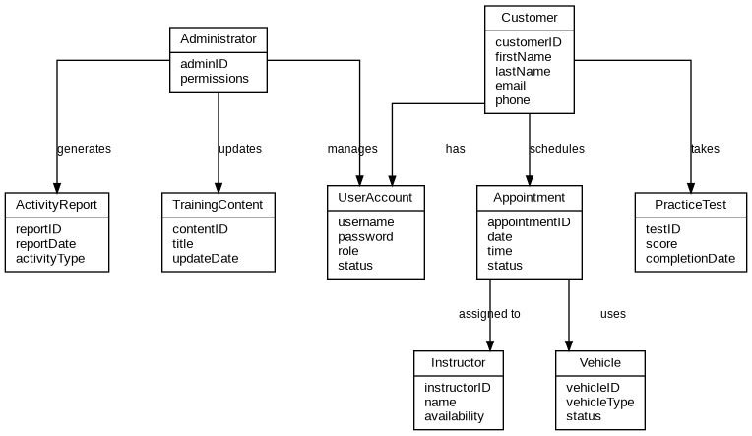

Technical Requirements
Requirement Type | Description
Hardware | The DriverPass system will require cloud hosted servers to store customer information, appointments, lesson records, reports, and training materials. Employees and administrators will need computers with internet access. Instructors may use tablets or mobile devices to view appointments and record lesson results.
Software | The system will operate through a web browser and support Windows, macOS, Android, and iOS devices. A database management system will store customer accounts, appointment information, training content, payments, and practice test results. Secure authentication software will be used to protect user accounts and passwords.
Tools | The system will use cloud hosting services, database tools, web application tools, and reporting tools. Administrators will use management tools to update training content, manage user accounts, manage schedules, and monitor system activity.
Infrastructure | The system requires reliable internet access, cloud based servers, secure data storage, and encrypted communication. The system must also support DMV update integration, so training materials remain current. These requirements support DriverPass by keeping scheduling, testing, and account management available and secure.

